Sofian
Alexandre Castonguay
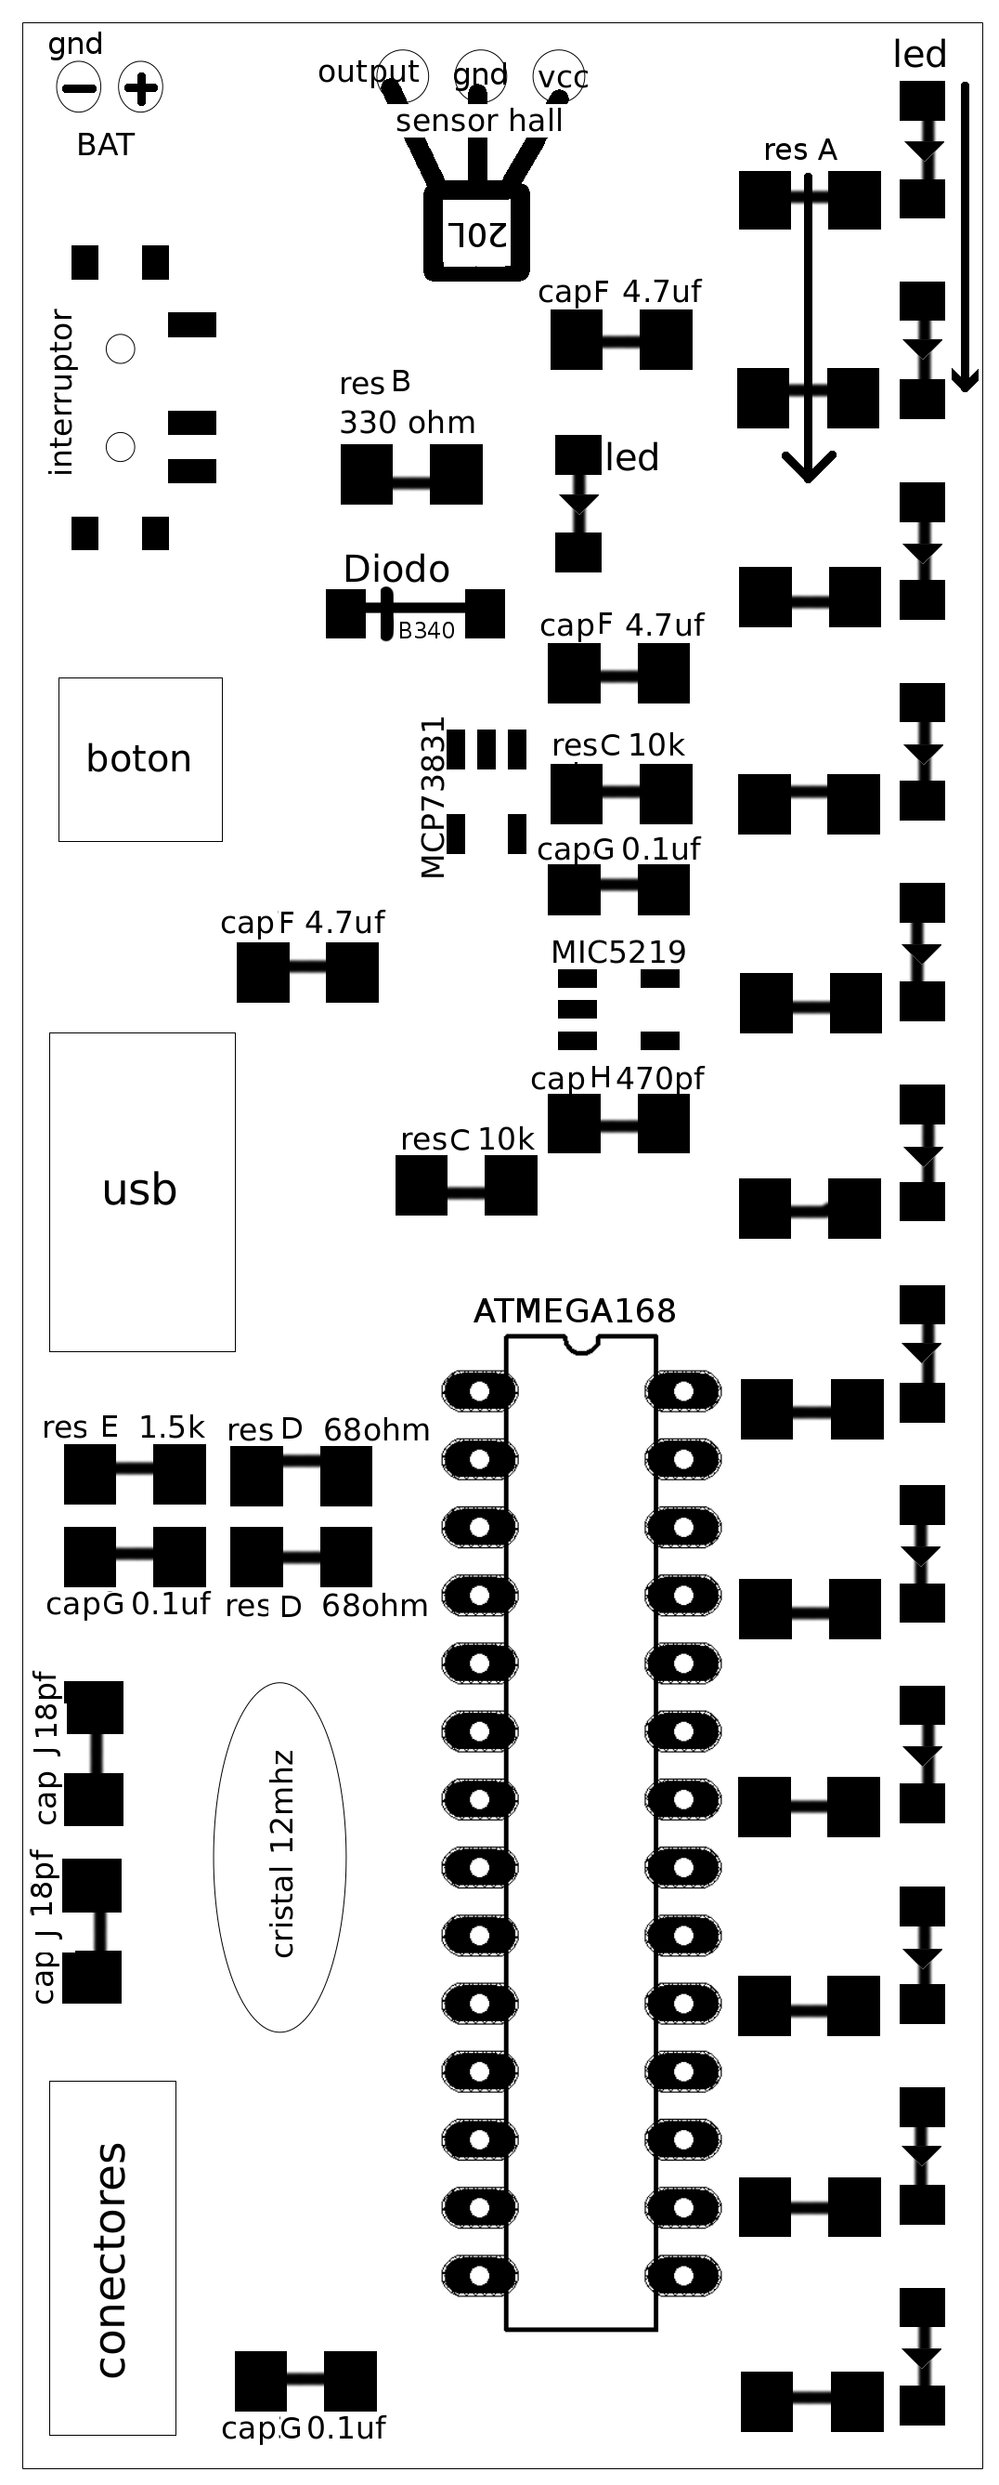
Thomas Ouellet Fredericks
Mariangela Aponte Nuñez

http://wiki.agitpov.net

Underlined parts are directional.

1-SURFACE MOUNT
13x led green dots toward the bottom
12x res A 12 of one of the following:
68 ohm – 680
51 ohm – 510
180 ohm – 181
1x res B 330 ohm - 331
2x res C 10k ohm - 103
2x res D 68 ohm - 680
1x res E 1.5k ohm – all black
3x cap F 4.7 uF – dark brown, thicker
3x cap G 0.1 micro farads – mid brown
1x cap H 470 pico farads – pale brown
2x cap J 18 pico farads - white
1x Diodo diode B340A
1x MCP73831 KDUM charger
1x MIC5219 LG33 regulator
1x interruptor 3D

2-THROUGH HOLE

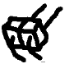
1x BAT other side of board
1x sensor hall A20L
1x boton 2 2
1x USB
1x cristal 12mhz
1x ATMEGA168

